[**https://docs.microsoft.com/en-us/learn/modules/principles-cloud-computing/**](https://docs.microsoft.com/en-us/learn/modules/principles-cloud-computing/)

**Microsoft Azure Cours**

**Module 1: Azure fundamentals Cloud Concepts - Principles of cloud computing**

**Learning objectives**

* Explore common cloud computing services
* Explore the benefits of cloud computing
* Decide which cloud deployment model is best for you

**Cloud computing services**

* **Goal**: Make running a business easier & more efficient whether it’s a small start-up or a large enterprise.
* Provide a wide range of services meeting every business needs
* **Computing choices:** VMs, Containers, Serverless computing

**Containers:** provide a consistent, isolated execution environment for applications.

* Similar to VMs but don’t required a guest OS.
* App & all its dependencies is packaged into a container and a Standard Runtime Environment is used to execute the app.

**Ex:** Docker-open source project providing efficient lightweight approach to app deployment

**Benefits**:

* portability of the container makes it easy for applications to be deployed in multiple environments,
* either on-premises or in the cloud
* often with no changes to the application.

**Serverless computing:**

* <run app code without creating, configuring or maintaining server.
* App broken into separate functions running when triggered by some action.
* You only pay for the processing time used by each function as it executes. VMs and containers are charged while they're running

**Cloud computing 7 Benefits:**

Existing businesses might choose a gradual movement to save money on infrastructure and administration costs (referred to as "lift and shift"), while a new company might start in the cloud.

* It's cost-effective(rentable):
* Pay-as-you-go/consumption based - paiement à l’utilisation /paiement basé sur la consommation.
* No upfront infrastructure costs or purchasing, managing infrastructure
* Pay for what needed & stop paying when not needed
* It's scalable (scalable):
* Vertical /horizontal scaling – mise à l’échelle verticale /horizontale
* Vertical scaling(scale- up) : adding more resources to power a server
* Hoziontale scaling(scale -out) : adding more servers to run as one unit
* It's elastic (élastique):
* Can add or remove resources automatically based on workload changes.
* It's current (tjrs à jour) :
* Focus on what matters as cloud provider take care to maintain and update the hardware’s and

Software’s provided

* It's reliable (fiable) :
* Provide data backup, disaster recovery, data replication and perform fault tolerance operations to ensure a replacement as soon as a component fail so as not to impact your customers.
* It's global (mondial) :
* Located in different regions and all over the globe
* Give best response time depending on the customer locality
* It's secure (sécurisé) :
* Provide physical security: who can access building, data center, server racks ….
* Provide Digital security: who can connect to you systems and data over network
* Provide different set of policies, technologies, controls, and expert technical skills….

**Summary**

Cloud computing makes running a business easier. It's cost-effective, scalable, elastic, current, reliable, and secure. This means you're able to spend more time on what matters and less time managing the underlying details.

**Compliance terms and requirements (Conditions et exigences de confomité):**

**How cloud provider help you comply with regulations and standards?**

* How compliant (dégré de conformité) towardSensitive data, services offered
* Provide physical security: who can access building, data center, server

**Compliance Offerings**

* Criminal Justice Information Services (CJIS): US State/ Local agency… FBI’s
* **Cloud Security Alliance (CSA) STAR Certification**: ISO/IEC 27001 & Cloud Controls Matrix (CCM)
* **General Data Protection Regulation (GDPR) -** As of May 25, 2018, a European privacy law
* **EU Model Clauses**: move customers data outside EU
* Health Insurance Portability and Accountability Act (HIPAA): US federal law
* **International Organization for Standardization (ISO) and the International Electrotechnical Commission (IEC) 27018**
* Multi-Tier Cloud Security (MTCS) Singapore
* **Service Organization Controls (SOC) 1, 2, and 3:**

Microsoft-covered cloud services are audited at least annually against the SOC report framework by independent third-party auditors. That audit covers controls for data security, availability, processing integrity, & confidentiality as applicable to in-scope trust principles for each service.

* National Institute of Standards and Technology (NIST) Cybersecurity Framework (CSF):

consists of standards, guidelines, & best practices to manage cybersecurity-related risks

* UK Government G-Cloud.

**Economies of scale**

* Ability to work efficiently and at low-cost per unit when operating at larger scale.
* ***Benefits to cloud services provider***: tax savings, lower power, cooling, and high-speed network connectivity prices between sites
* ***Benefits to consumers***: Lower hardware’s prices

**Capital exp. (CapEx) Vs opé. expenditure (OpEx) /**Dépenses en capital vs dép. de fonctionnement

**CapEx**:

spending money on physical infrastructure up front, and then deducting that expense from your tax bill over time. It’s an upfront cost, which has a value that reduces over time.

**CapEx computing costs**

* Server, storage, network, backup & archive, organization continuity & disaster recovery
* Datacenter infrastructure, technical personnel

**Benefits of CapEx**

* Expenses planned at start of project/budget period
* Fixed costs - know how much is being spent
* Appealing – know expenses before project start due to limited budget

**OpEx:**

spending money on services or products now and being billed for them now. Deduct this expense from your tax bill in the same year. There is no upfront cost. You pay for a service or product as you use it.

**OpEx computing costs**

* Leasing software & customized features
* Scaling charges based on usage/demand instead of fixed hardware or capacity
* Billing at the user or organization level

**Benefits of OpEx**

* **Challenge**: how to meet demand & growth - as they can outpaced expectation (unpredictability)
* try new services or products without investment in equipment
* But pay much or little for infrastructure required
* OpEx is appealing when the demands fluctuate or is unknown
* Cloud agility – ability to rapidly change IT Infrastructure to adapt to the evolving needs of a business.

**3 Cloud deployment models**

Where your data is stored and how your customers interact with it.

Depends on how much of your own infrastructure you want or need to manage.

* Public cloud :
* Common approach
* Cost-effective, high scalability/agility, current
* Minimal tech skills required to set up.
* **Disadvantages:** can’t meet meet strict security, compliance, or legal requirements
* Private cloud :
* Create a cloud environment in your datacenter and provide self-service access to compute resources to users in your organization
* You are responsible for the maintenance of the hardware and software services you provide
* Private clouds can meet strict security, compliance, or legal requirements
* **Disadvantages:** CapEx costs **…**
* Hybrid cloud :
* Combines public & private clouds, allowing you to run your applications in the most appropriate location
* When some data can’t be exposed publicly (such as medical data) which needs to be held in your private datacenter.
* **Disadvantages**: it can be
  + expensive than selecting 1 deployment model since it involves some CapEx cost up front
  + complicated to set up and manage

**Summary**

Cloud computing is flexible & gives you the ability to choose how you want to deploy it. The cloud deployment model you choose depends on:

* + your budget, and on your security,
  + scalability, and maintenance needs.

**3 Types of cloud services**

Used in conversation, documentation and training.

* **IaaS** : Infrastructure as a service
* most flexible category
* shared responsibility model
* give you control over the provided hardware that runs your app
* renting hardware instead of buying it
* **Use cases:** Migrating workloads, test and development, Storage, backup, and recovery
* **Upfront costs**: There are no upfront costs. Users pay only for what they consume.
* **User ownership**: responsible for the purchase, installation, configuration, and management of their own software, operating systems, middleware, and applications.
* **Cloud** **provider** **ownership**: responsible for ensuring that the underlying cloud infrastructure (virtual machines…) is available for the user.
* **PaaS**: Platform as a service
* provides an environment for building, testing, and deploying software applications
* **Goal**: to help you create an application quickly without managing the underlying infrastructure
* **Use cases:** Development framework, Analytics or business intelligence
* **Upfront** **costs**: There are no upfront costs. Users pay only for what they consume.
* **User** **ownership**: responsible for the development of their own applications.
  + Not responsible for managing the server or infrastructure.
  + Allows user to focus on the application or workload they want to run.
* **Cloud** **provider** **ownership**:
  + responsible for operating system management, network, and service configuration.
  + responsible for everything apart from the application that a user wants to run.
  + they provide a complete managed platform on which to run the application.
* **SaaS**: Software as a service
* software that is centrally hosted and managed for the end customer
* based on an architecture where 1 version of the application is used for all customers,
* and licensed through a monthly or annual subscription
* **Eg**: Microsoft 365, Skype, and Dynamics CRM Online
* **Use cases:** can’t meet compliance, or legal requirements
* **Upfront costs**: Users have no upfront costs; pay a subscription, typically on a monthly/ annual basis.
* **User ownership**: Users just use the application software; they are not responsible for any maintenance or management of that software.
* **Cloud** **provider** **ownership**: responsible for the provision, management, & maintenance of the application software.

**Management responsibilities**

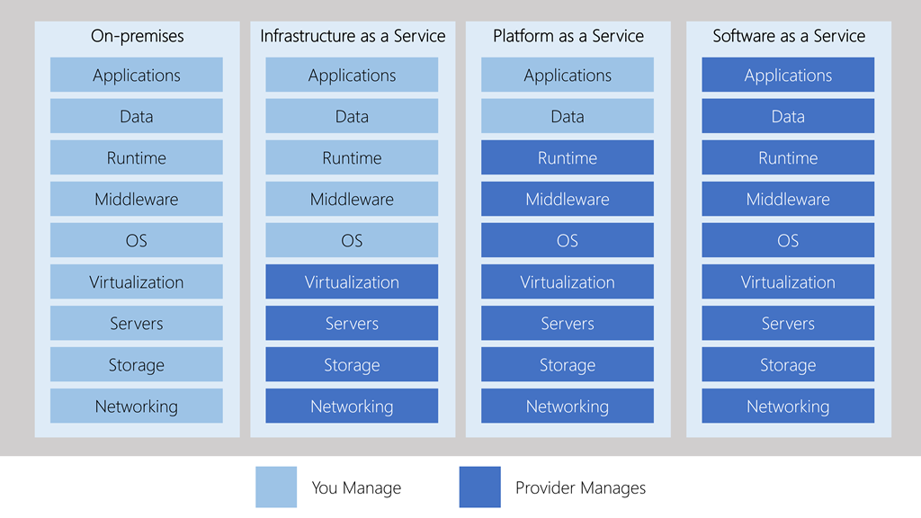

* **IaaS**
  + requires the most user management of all the cloud services.
  + The user is responsible for managing the operating systems, data, and applications.
* **PaaS** 
  + requires less user management. The cloud provider manages the operating systems,
  + the user is responsible for the applications and data they run and store.
* **SaaS** 
  + requires the least amount of management. The cloud provider is responsible for managing everything
  + the end user just uses the software.

**Combine cloud services to fit your needs**

* **IaaS, PaaS, and SaaS** each contain different levels of **managed services**.
* Cloud's flexibility allows you to use any combination of infrastructure that provides you with the maximum result.
* You could use Microsoft 365 on your company's computers (SaaS)
* in Azure, you could host your VMs (IaaS) and use Azure SQL Database (PaaS) to store your data.

**Module 1 Summary:**

* What is cloud computing, and what its key characteristics are. Here are some of the things you covered:
  + Different types of cloud models & considerations of using those different models.
  + key terms & concepts such as high availability, agility, elasticity, fault tolerance, and CapEx vs. OpEx.
  + The different cloud services available, the benefits of using the different types, and the management responsibilities under each service type.
  + Cloud models such as public, private and hybrid, and what the key characteristics of each model are.
  + The different types of cloud service available: IaaS, PaaS, and SaaS; what the key characteristics of each service are and when you would choose one over the other.

**Microsoft Azure**

Azure is Microsoft's cloud computing platform. Azure provides over 100 services that enable you to do everything from running your existing applications on virtual machines to exploring new software paradigms such as intelligent bots and mixed reality.

Here are just a few kinds of services you'll find on Azure:

* **Compute** services such as VMs and containers that can run your applications
* **Database** services that provide both relational and NoSQL choices
* **Identity** services that help you authenticate and protect your users
* **Networking** services that connect your datacenter to the cloud, provide high availability or host your DNS domain
* **Storage** solutions that can accommodate massive amounts of both structured and unstructured data
* **AI and machine-learning** services can analyze data, text, images, comprehend speech, and make predictions using data — changing the world of agriculture, healthcare, and much more.
* And many more!

**Learn more**

Stay on the [Azure Fundamentals Learning Path](https://docs.microsoft.com/en-us/learn/paths/azure-fundamentals/) to learn more about how Microsoft Azure can help you build more secure, reliable, performant applications in the cloud.

In addition, here are some places to go to learn more about what we've covered today:

[Cloud Computing Terms](https://azure.microsoft.com/overview/cloud-computing-dictionary/)

[What is Azure?](https://azure.microsoft.com/overview/cloud-computing-dictionary/)

[Azure compliance offerings](https://www.microsoft.com/trustcenter/compliance/complianceofferings)

[Azure Architecture Center](https://docs.microsoft.com/en-us/azure/architecture/guide/)

[Overview of Azure compute options](https://docs.microsoft.com/en-us/azure/architecture/guide/technology-choices/compute-overview)

6 Modules NEW PATH - **Module 1: Azure Fundamentals part 1: Describe core Azure concepts**

**Learning objectives**

* Describe the basic concepts of cloud computing.
* Determine whether Azure is the right solution for your business needs.
* Differentiate between the different methods of creating an Azure subscription.

**Microsoft Azure**

* Microsoft cloud computing solution platform with an ever-expending set of services.
* To help you build solutions to meet your business goals.
* Support I/P/S – aaS.
* Services (VMs running in cloud, web sites and database hosting)
* Pay as you go – VM in the cloud from scratch….
* Provide Cloud-based storage -backup …
* Popular dev frameworks, easily deploy, scale …
* Azure Functions: create events.
* Azure Container Instances & Kubernetes: containerized app with fully managed services.
* Databases: relational, In memory db.
* Azure Cosmos DB: NoSQL APIs.
* AI, ML services empower dev & data scientist with a wide array of infrastructures.
* Azure Regional datacenters - permit to distribute your app globally
* Azure Portal - create, configure, control all your services using a single UI.

**What is cloud computing ?**

* Process of renting resources (storage/CPU cycles) from another company’s computers.
* That company is called a cloud provider (Microsoft/Amazon/ Google) and is responsible for the physical hardware required to execute your work, and keeping it up to date.
* That company, typically offered the computing services such as:
  + Compute power: Linux servers/web apps used for computation & processing tasks
  + Storage: files & databases
  + Networking: secure connection between them and you
  + Analytics: visualizing telemetry & performance data

**Why is cloud computing typically cheaper to use?**

* + Lower your operating costs.
  + Run your infrastructure more efficiently.
  + Scale as your business needs change.

**Why should I move to the cloud?**

To **power your services** and **deliver innovative** and **novel user experiences** more quickly, the cloud provides **on-demand access** to:

* A nearly limitless pool of raw compute, storage, and networking components.
* Speech recognition and other cognitive services that help make your application stand out from the crowd.
* Analytics services that deliver telemetry data from your software and devices.

**What are some cloud computing advantages ?**

* **High** **availability**: Depending on the service-level agreement that you choose, your cloud-based applications can provide a continuous user experience with no apparent downtime even when things go wrong
* **Scalability**: Vert./Horiz. – add more power to VM / add more VMs to config.
* **Elasticity: autoscaling- resources always available when you need them**
* **Agility: resources can be deployed & configured quickly as app requirements change**
* **Geo**-**distribution**: App & data can be deployed to regional datacenters around the globe, so your customers always have the best performance in their region.
* **Disaster** **recovery**: safety of your data - backup services, data replication and geo-distribution

**What are cloud service models?**

* **IaaS**
  + requires the most user management of all the cloud services.
  + user is responsible for managing the operating systems, data, and applications.
* **PaaS** 
  + requires less user management. The cloud provider manages the operating systems,
  + user is responsible for the applications and data they run and store.
* **SaaS** 
  + requires the least amount of management. The cloud provider is responsible for managing everything
  + 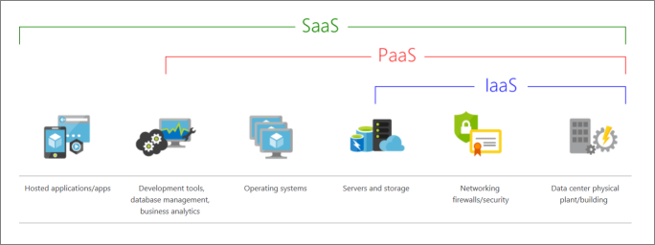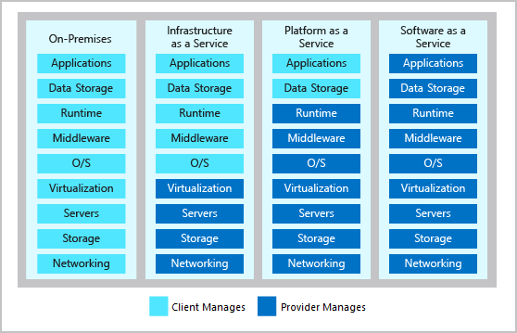the end user just uses the software.

**What is serverless computing?**

* <run app code> without creating, configuring or maintaining server.
* cloud service provider automatically provisions, scales, and manages the infrastructure required to run the code.
* serverless architectures are highly scalable and event-driven.
* They use resources only when a specific function or trigger occurs
  + **Benefits?**
    - Developers focus on the business logic and deliver more value to the core of the business.
    - Serverless computing helps teams increase their productivity and bring products to market faster.
    - Allows organizations to better optimize resources and stay focused on innovation.

**3 Cloud deployment models**

Where your data is stored and how your customers interact with it.

Depends on how much of your own infrastructure you want or need to manage.

* Public cloud:
  + Services are offered over the public internet and available to anyone who wants to purchase them.
  + Cloud resources like servers and storage are owned and operated by a third-party cloud service provider and delivered over the internet.
* Private cloud:
  + Computing resources are used exclusively by users from one business or organization.
  + A private cloud can be physically located at your organization's on-site datacenter. It also can be hosted by a third-party service provider.
* Hybrid cloud:
  + This computing environment combines a public cloud and a private cloud by allowing data and applications to be shared between them.

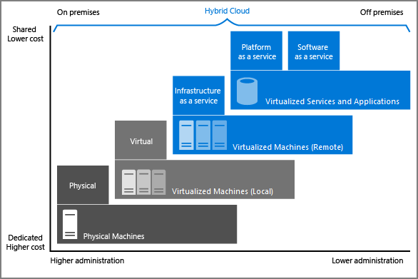

**Microsoft Azure**

* Azure is a continually expanding set of cloud services that help your organization meet your current and future business challenges.
* Azure gives you the freedom to build, manage, and deploy applications on a massive global network using your favorite tools and frameworks.

**What does Azure offer?**

* **Be ready for the future**: Continuous innovation from Microsoft supports your development today and your product visions for tomorrow.
* **Build on your terms**: You have choices. With a commitment to open source, and support for all languages and frameworks, build how you want and deploy where you want to.
* **Operate hybrid seamlessly**: On-premises, in the cloud, and at the edge--we'll meet you where you are. Integrate and manage your environments with tools and services designed for a hybrid cloud solution.
* **Trust your cloud**: Get security from the ground up, backed by a team of experts, and proactive compliance trusted by enterprises, governments, and startups.

**What can I do with Azure?**

* provides more than 100 services that enable you to do everything from running your existing applications on virtual machines to exploring new software paradigms, such as intelligent bots and mixed reality.
* Many teams start exploring the cloud by moving their existing applications to virtual machines that run in Azure. Migrating your existing apps to virtual machines is a good start, but the cloud is much more than a different place to run your virtual machines.
* Azure provides AI and machine-learning services that can naturally communicate with your users through vision, hearing, and speech. It also provides storage solutions that dynamically grow to accommodate massive amounts of data. Azure services enable solutions that aren't feasible without the power of the cloud.

**What can I do with Azure?**

* provides more than 100 services that enable you to do everything from running your existing applications on virtual machines to exploring new software paradigms, such as intelligent.

**How does Azure work?**

* Virtualization-hypervisor-.

**What is the Azure portal?**

* Web-based, unified console that provides an alternative to command-line tools. You can manage your Azure subscription by using a graphical user interface.
* You can: Build, manage, and monitor everything from simple web apps to complex cloud deployments.
* Create custom dashboards for an organized view of resources.
* Configure accessibility options for an optimal experience.

**What is Azure Marketplace?**

* Helps you connect users with Microsoft partners, independent software vendors, and startups that are offering their solutions and services, which are optimized to run on Azure.
* Azure Marketplace customers can find, try, purchase, and provision applications and services from hundreds of leading service providers. All solutions and services are certified to run on Azure.
* The solution catalog spans several industry categories (open-source container platforms, virtual machine images, databases, application build and deployment software, developer tools, threat detection, and blockchain).
* Using Azure Marketplace, you can provision end-to-end solutions quickly and reliably, hosted in your own Azure environment. At the time of writing, there are more than 8,000 listings.
* Azure Marketplace is designed for IT pros and cloud developers interested in commercial and IT software.
* Microsoft partners also use it as a launch point for all joint go-to-market activities.

**Tour of Azure (high-level) services**

* Compute Services: VM, containers, Serveless
* Cloud storage
* Networking
* App Hosting
* Artificial Intelligence
* Internet of Things
* Integration
* Security

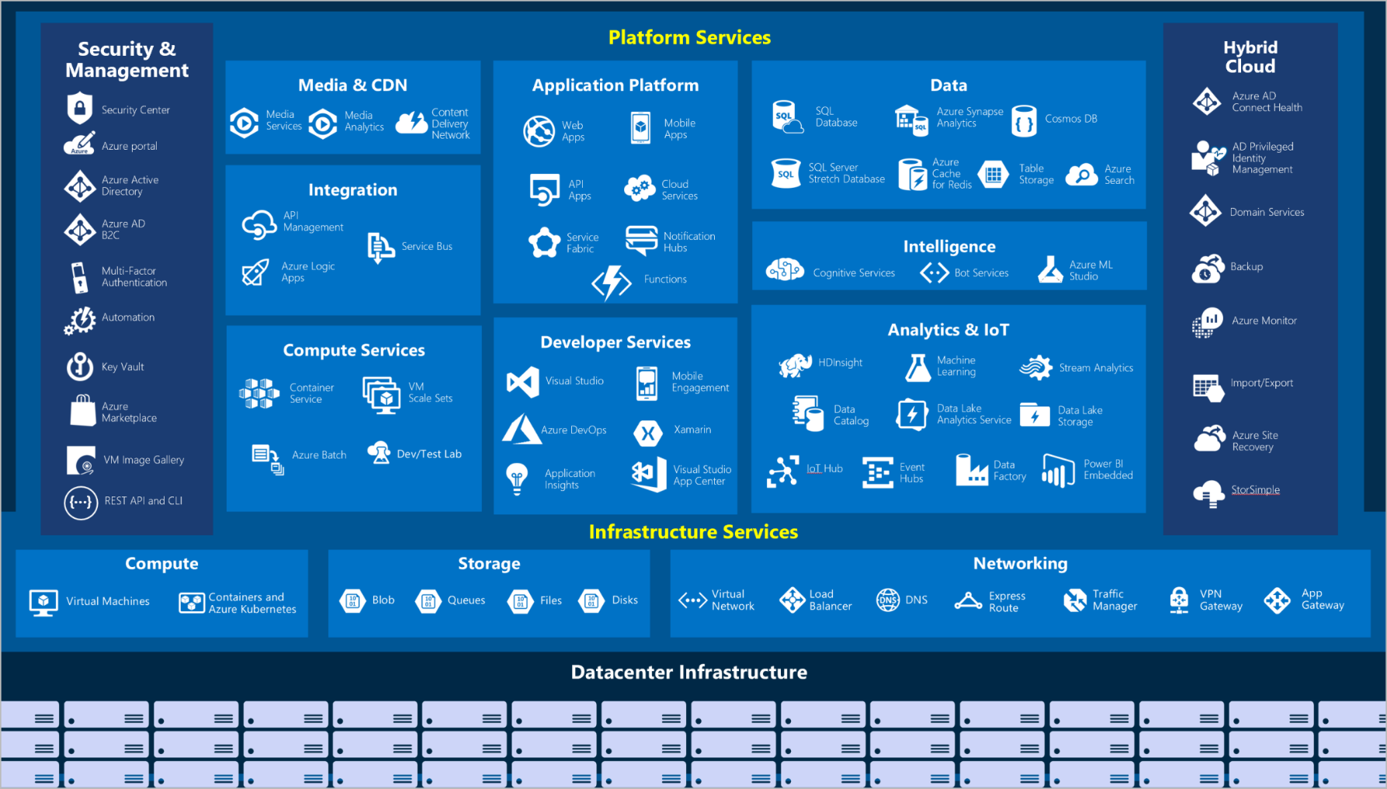

**Compute**

Compute services are often one of the primary reasons why companies move to the Azure platform. Azure provides a range of options for hosting applications and services. Here are some examples of compute services in Azure.

**Service name Service function**

Azure Virtual Machines : windows or Linux virtual machines (VMs) hosted in Azure

Azure Virtual Machine Scale Sets: scaling for Windows or Linux VMs hosted in Azure

Azure Kubernetes Service: cluster management for VMs that run containerized services

Azure Service Fabric: distributed systems platform that runs in Azure or on-premises

Azure Batch: managed service for parallel and high-performance computing applications

Azure Container Instances: containerized apps run on Azure without provisioning servers/VMs

Azure Functions: an event-driven, serverless compute service

**Networking**

Linking compute resources and providing access to applications is the key function of Azure networking. Networking functionality in Azure includes a range of options to connect the outside world to services and features in the global Azure datacenters.

Here are some examples of networking services in Azure.

**Service name** **Service function**

Azure Virtual Network Connects VMs to incoming virtual private network (VPN) connections

Azure Load Balancer Balances inbound and outbound connections to applications or service endpoints

Azure Application Gateway Optimizes app server farm delivery while increasing application security

Azure VPN Gateway Accesses Azure Virtual Networks through high-performance VPN gateways

Azure DNS Provides ultra-fast DNS responses and ultra-high domain availability

Azure Content Delivery Network Delivers high-bandwidth content to customers globally

Azure DDoS Protection Protects Azure-hosted applications from distributed denial of service (DDOS) attacks

Azure Traffic Manager Distributes network traffic across Azure regions worldwide

Azure ExpressRoute Connects to Azure over high-bandwidth dedicated secure connections

Azure Network Watcher Monitors and diagnoses network issues by using scenario-based analysis

Azure Firewall Implements high-security, high-availability firewall with unlimited scalability

Azure Virtual WAN Creates a unified wide area network (WAN) that connects local and remote sites

**Storage**

Azure provides four main types of storage services.

**Service name** **Service function**

Azure Blob storage: Storage service for very large objects, such as video files or bitmaps

Azure File storage: File shares that can be accessed and managed like a file server

Azure Queue storage: A data store for queuing and reliably delivering messages between applications

Azure Table storage: A NoSQL store that hosts unstructured data independent of any schema

These services all share several common characteristics:

* **Durable** and highly available with redundancy and replication.
* **Secure** through automatic encryption and role-based access control.
* **Scalable** with virtually unlimited storage.
* **Managed**, handling maintenance and any critical problems for you.
* **Accessible** from anywhere in the world over HTTP or HTTPS.

**Mobile**

With Azure, developers can create mobile back-end services for iOS, Android, and Windows apps quickly and easily. Features that used to take time and increase project risks, such as adding corporate sign-in and then connecting to on-premises resources such as SAP, Oracle, SQL Server, and SharePoint, are now simple to include.

Other features of this service include:

* Offline data synchronization.
* Connectivity to on-premises data.
* Broadcasting push notifications.
* Autoscaling to match business needs.

**Web**

Azure includes first-class support to build and host web apps and HTTP-based web services. The following Azure services are focused on web hosting.

**Service** **name** **Description**

* Azure App Service: Quickly create powerful cloud web-based apps.
* Azure Notification Hubs: Send push notifications to any platform from any back end.
* Azure API Management: Publish APIs to developers, partners, and employees securely and at scale.
* Azure Cognitive Search: Deploy this fully managed search as a service.
* Web Apps feature of Azure App Service: Create and deploy mission-critical web apps at scale.
* Azure SignalR Service: Add real-time web functionalities easily.

**IoT**

Many services can assist and drive end-to-end solutions for IoT on Azure.

**Service** **name** **Description**

IoT Central: Fully managed global IoT software as a service (SaaS) solution that makes it easy to connect, monitor, and manage IoT assets at scale

Azure IoT Hub: Messaging hub that provides secure communications between and monitoring of millions of IoT devices

IoT Edge: Fully managed service that allows data analysis models to be pushed directly onto IoT devices, which allows them to react quickly to state changes without needing to consult cloud-based AI models

**Big data**

Data comes in all formats and sizes. When we talk about big data, we're referring to large volumes of data. Data from weather systems, communications systems, genomic research, imaging platforms, and many other scenarios generate hundreds of gigabytes of data. This amount of data makes it hard to analyze and make decisions. It's often so large that traditional forms of processing and analysis are no longer appropriate.

Open-source cluster technologies have been developed to deal with these large data sets. Azure supports a broad range of technologies and services to provide big data and analytic solutions.

**Service name** **Description**

Azure Synapse Analytics: Run analytics at a massive scale by using a cloud-based enterprise data warehouse that takes advantage of massively parallel

processing to run complex queries quickly across petabytes of data.

Azure HDInsight: Process massive amounts of data

with managed clusters of Hadoop clusters in the cloud.

Azure Databricks: Integrate this collaborative Apache Spark-based

analytics service with other big data services in Azure.

**AI**

AI, in the context of cloud computing, is based around a broad range of services, the core of which is machine learning. Machine learning is a data science technique that allows computers to use existing data to forecast future behaviors, outcomes, and trends. Using machine learning, computers learn without being explicitly programmed.

Forecasts or predictions from machine learning can make apps and devices smarter. For example, when you shop online, machine learning helps recommend other products you might like based on what you've purchased. Or when your credit card is swiped, machine learning compares the transaction to a database of transactions and helps detect fraud. And when your robot vacuum cleaner vacuums a room, machine learning helps it decide whether the job is done.

Here are some of the most common AI and machine learning service types in Azure.

**Service name** **Description**

Azure Machine Learning Service Cloud-based environment you can use to develop, train, test, deploy, manage, and track machine learning models. It can auto-generate a model and auto-tune it for you. It will let you start training on your local machine, and then scale out to the cloud.

Azure Machine Learning Studio Collaborative visual workspace where you can build, test, and deploy machine learning solutions by using prebuilt machine learning algorithms and data-handling modules.

A closely related set of products are the cognitive services. You can use these prebuilt APIs in your applications to solve complex problems.

**Service name** **Description**

Vision Use image-processing algorithms to smartly identify, caption, index, and moderate your pictures and videos.

Speech Convert spoken audio into text, use voice for verification, or add speaker recognition to your app.

Knowledge mapping Map complex information and data to solve tasks such as intelligent recommendations and semantic search.

Bing Search Add Bing Search APIs to your apps and harness the ability to comb billions of webpages, images, videos, and news with a single API call.

Natural Language processing Allow your apps to process natural language with prebuilt scripts, evaluate sentiment and learn how to recognize what users want.

**DevOps**

DevOps brings together people, processes, and technology by automating software delivery to provide continuous value to your users. With Azure DevOps, you can create build and release pipelines that provide continuous integration, delivery, and deployment for your applications. You can integrate repositories and application tests, perform application monitoring, and work with build artifacts. You can also work with and backlog items for tracking, automate infrastructure deployment, and integrate a range of third-party tools and services such as Jenkins and Chef. All of these functions and many more are closely integrated with Azure to allow for consistent, repeatable deployments for your applications to provide streamlined build and release processes.

**Service name** **Description**

Azure DevOps Use development collaboration tools such as high-performance pipelines, free private Git repositories, configurable Kanban boards, and extensive automated and cloud-based load testing. Formerly known as Visual Studio Team Services.

Azure DevTest Labs Quickly create on-demand Windows and Linux environments to test or demo applications directly from deployment pipelines.